Introduction to Geography Unit Study Guide

Vocabulary Terms:
Quiz #1:
Cardinal direction distortion geographic information system (GIS)
Geography latitude intermediate direction
Longitude projection scale
Deposition equinox solstice
Biome climate ecosystem
Temperate zone water cycle Biodiversity
Deforestation emigrate Social structure
Fossil fuel industrialization natural resources
Pull factor push factor urbanization
Cultural diffusion culture social class

Quiz #2:
Consumer demand opportunity cost
Producer supply comparative advantage
Free trade productivity gross domestic product (GDP)
Tariff trade barrier authoritarian government
Constitution democracy federal system
Government monarchy unitary system
Anthropology archaeology chronology
Prehistory primary source secondary source

Quiz #1 (Unit 2 Lesson 5) topics and where they can be found in the textbook:

Total pages on this assessment: p. 10-53

- Cardinal vs Intermediate directions/ Longitude and Latitude p. 11

- Map Projections: p.13
  - Mollweide Projection/Equal Area Projection
  - Mercator Projection
  - Robinson Projection

- The Reasons for the Seasons p. 19-24

- Water Cycle/ Oceans and Climates p.31

- Environment, Resources, Human Influence p.37-40

- Reasons for Migration (Push/Pull Factors) p.42

- Families, Societies, Language Groups, Cultural Diffusion p. 47-48, 51

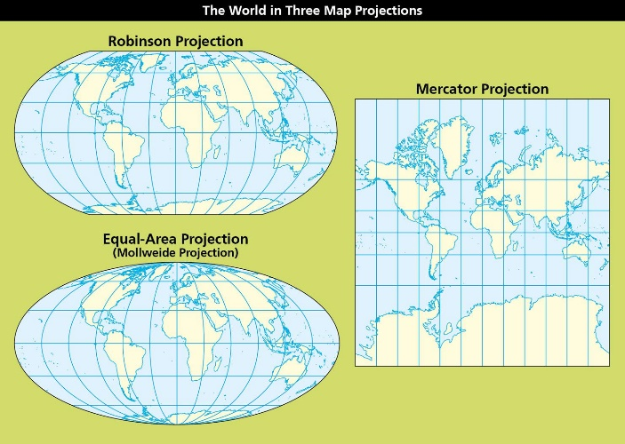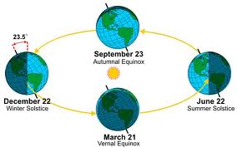
Quiz #2(Unit 2 Lesson 10) topics and where they can be found in the textbook:
Total pages on this assessment: p.54-89
- Econ Basics: p.55, 58-59
  - Wants, needs, and opportunity costs
  - What drives a free market?
- International Trade and Barriers to Trade p.65
- Government Basics: p. 73, 79
  - Characteristics of:
    - Absolute Monarchy
    - Authoritarian Dictatorship
    - Democratic Government
  - Rights vs. Responsibilities
- Organizing Time (Time lines) p. 84
- Primary/Secondary Sources p. 85
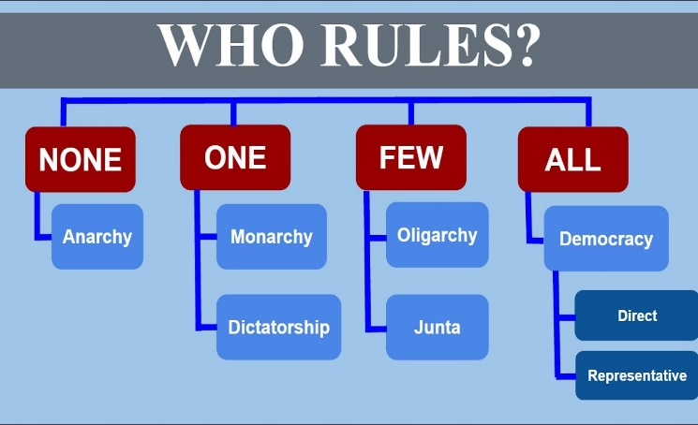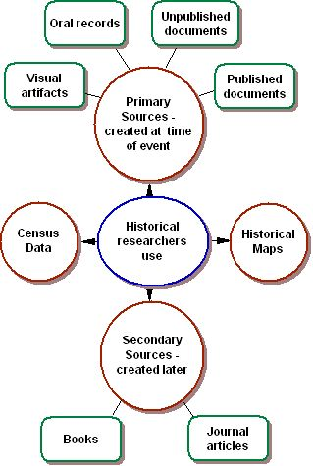
Unit Test (Unit 2 Lesson 12) topics and where they can be found in the textbook:
Total pages on this assessment: p. 10-94
- Maps, Aerial Photographs, and Map Projections: p. 13
  - Equal Area (Mollweide), Mercator, Robinson
- Identifying Layers of the Earth: p. 22
- Earthquake Causes: p. 25
- The Water Cycle p. 31
- Climate and Ecosystems: p. 34
- Renewable and Non-Renewable Resources: p. 37-40
- Causes of Migration (Push and Pull Factors): p. 42
- The Effects of Supply and Demand: p. 55
- Tariffs, Embargos, and Trade Barriers: p. 65
- Federal/Unitary Systems, Branches of Government: p. 75
- Meaning of Citizenship: p. 79
- Archeology vs Anthropology: p. 88
- Unit Review Activities: p. 91-94
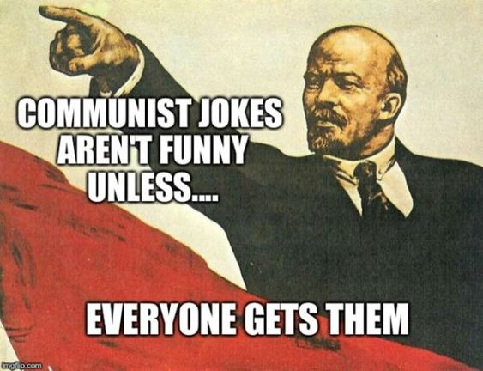
Unit Test Essay Topics:
What is the role of the government in a mixed economy? P.58

How does the tilt of Earth’s axis and its movement around the sun play a part in the changing of the seasons in the Northern Hemisphere? P.19-21

Describe the major physical and human features of the location where you live, such as the landscape, weather, and population.
What theme of geography are you using in your description? P.12

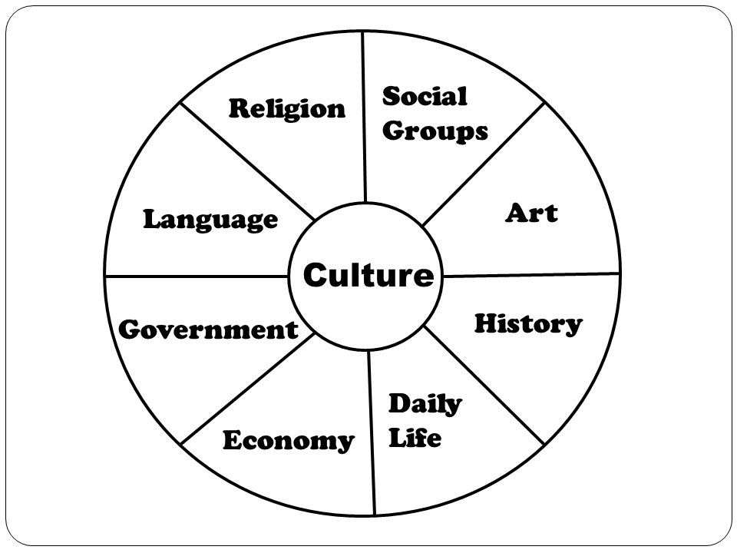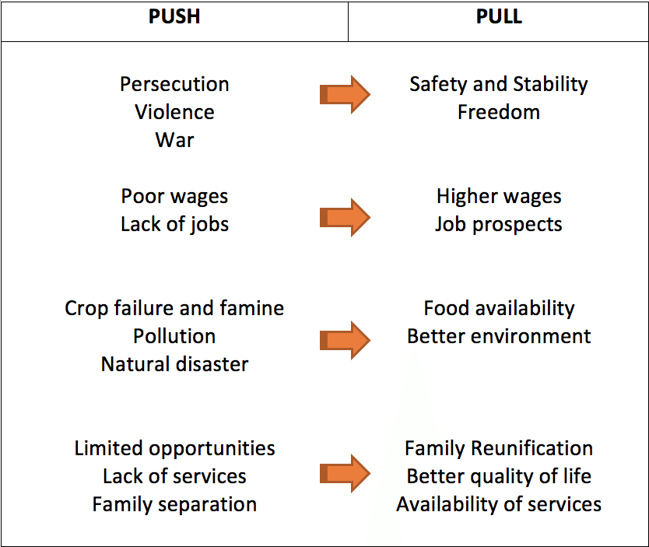

Equal Area/Mollweide Projection:
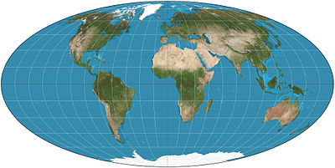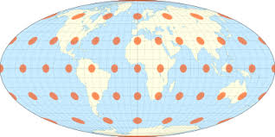

Robinson Projection:
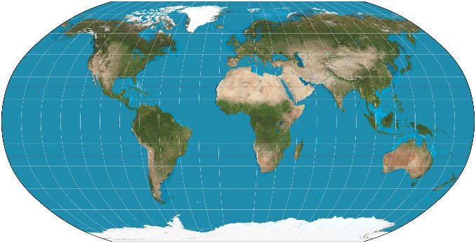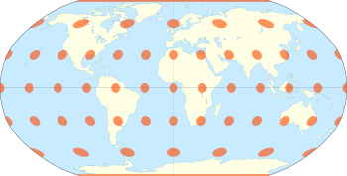

Mercator Projection:

